Marte Rodriguez

CIS 241

Final Project – Documentation

Screenshot 1 – Homepage (full screen)

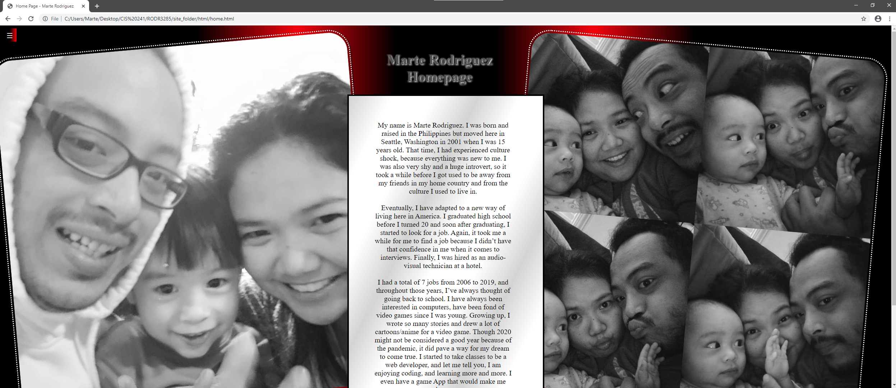

**This is my home page in full screen mode with my family. (I have ultra-wide monitor, that’s why the screen is wide)**

Screenshot 2 – Homepage Navigation button (full screen)

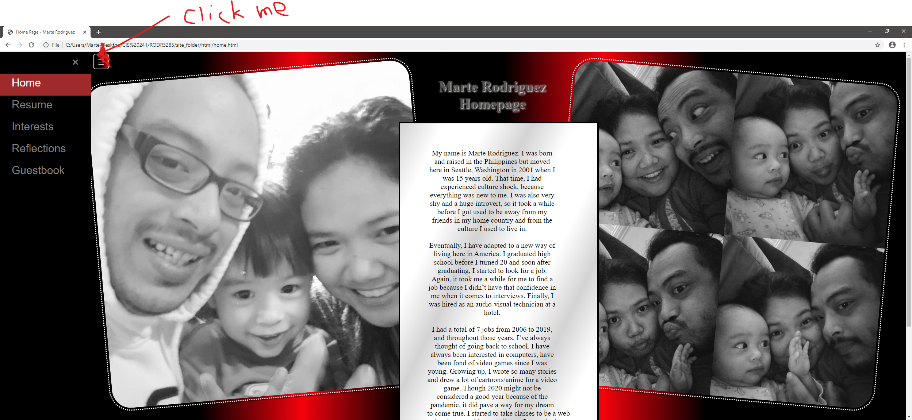

**Clicking the hamburger button on the top left opens up the navigation.**

Screenshot 3 – Homepage (small screen)

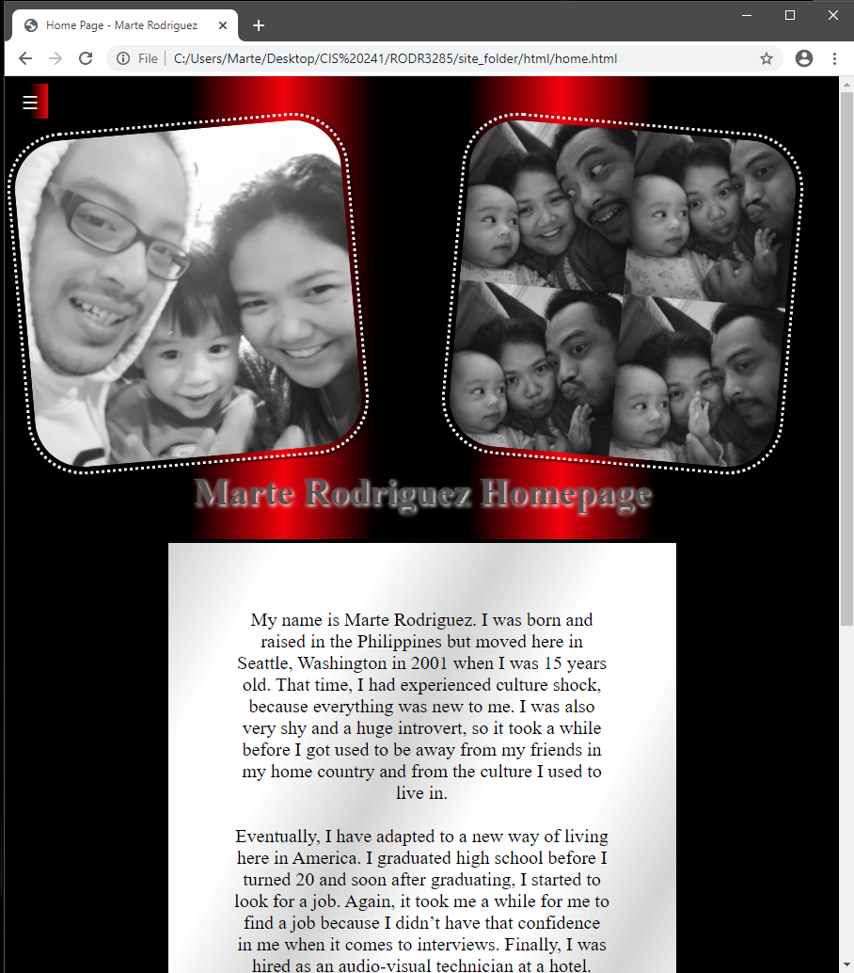

**This is what my homepage looks like when it is smaller.**

Screenshot 4 – Footer on the bottom of the page 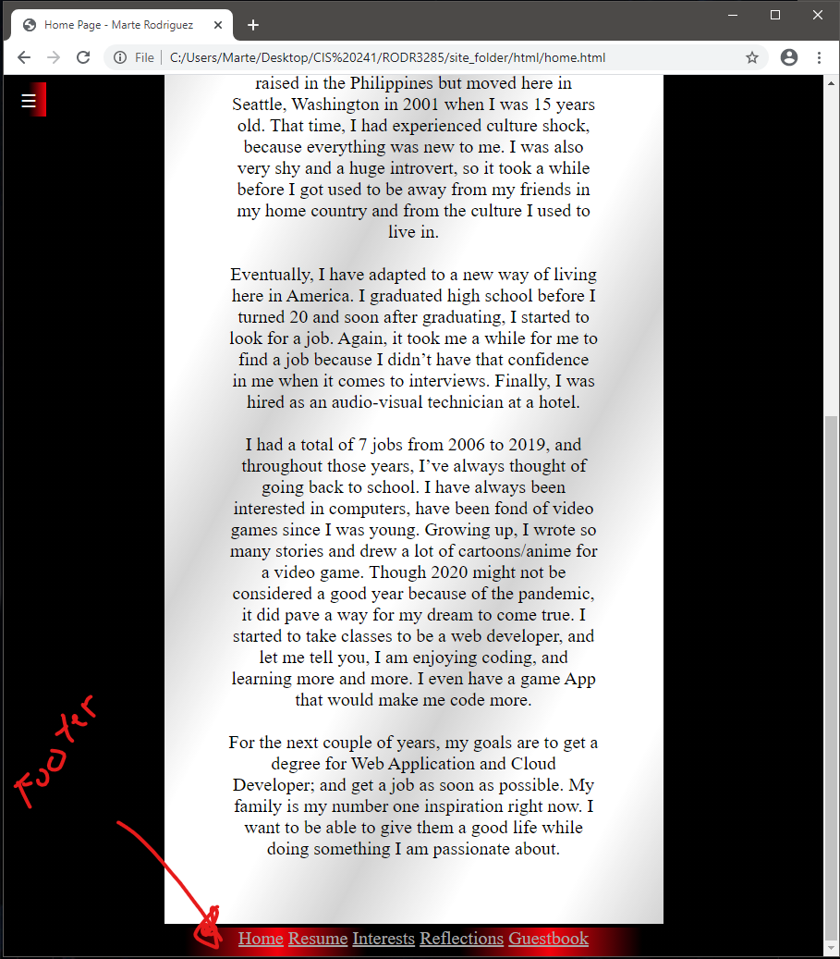

**Footer on the bottom of every page.**

Screenshot 5 – Homepage Navigation button (small screen)

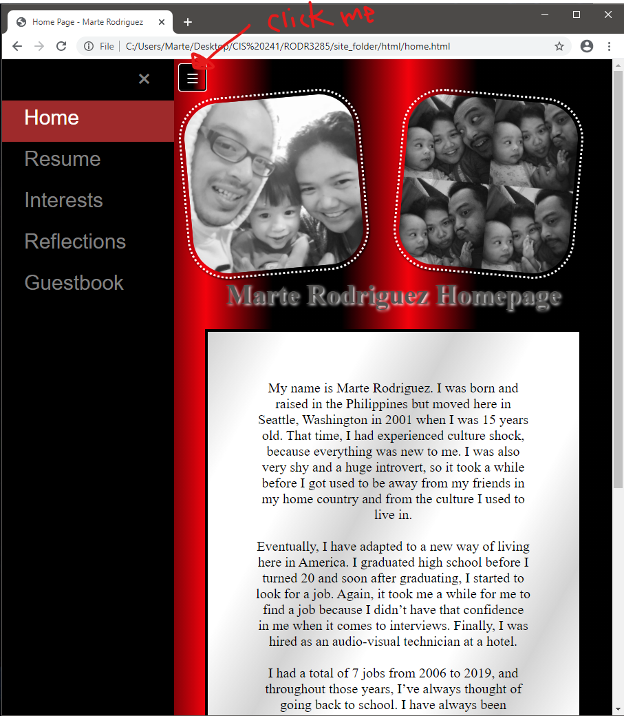

**My Homepage in small screen once navigation has been clicked.**

Screenshot 6 – Clicking a different page.

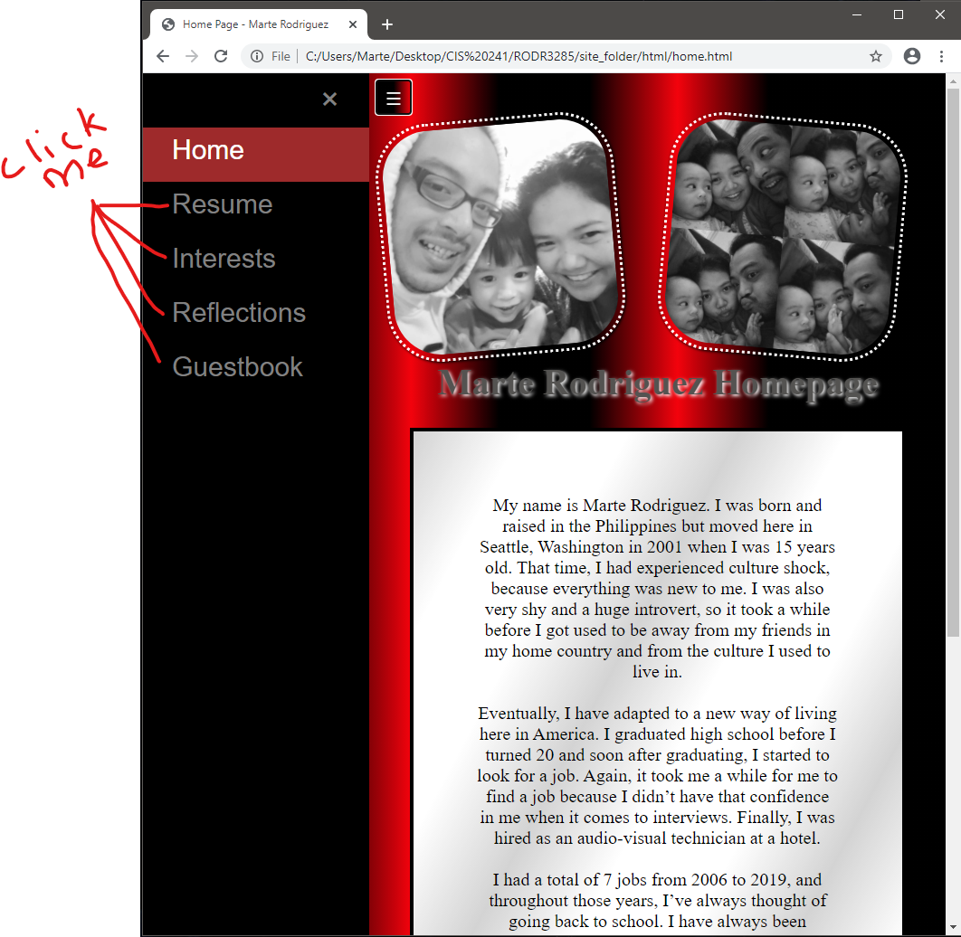

**Clicking on any of the page from the navigation screen moves you to the next screen. We’re going to go in order and move to resume page next.**

Screenshot 7 – Resume Page (full screen)

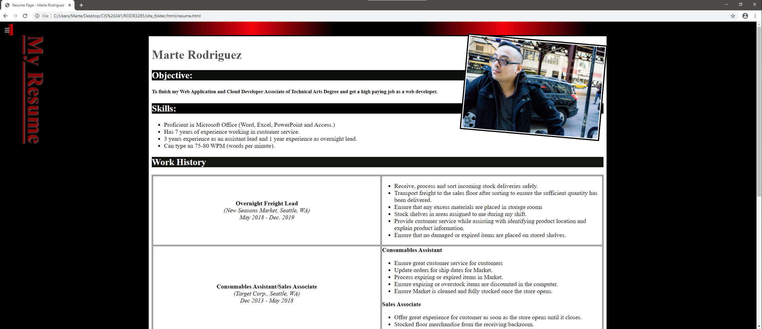

**My resume page (with a picture of me) in full screen mode and a table with my work history.**

Screenshot 8 – Resume page with navigation panel open.

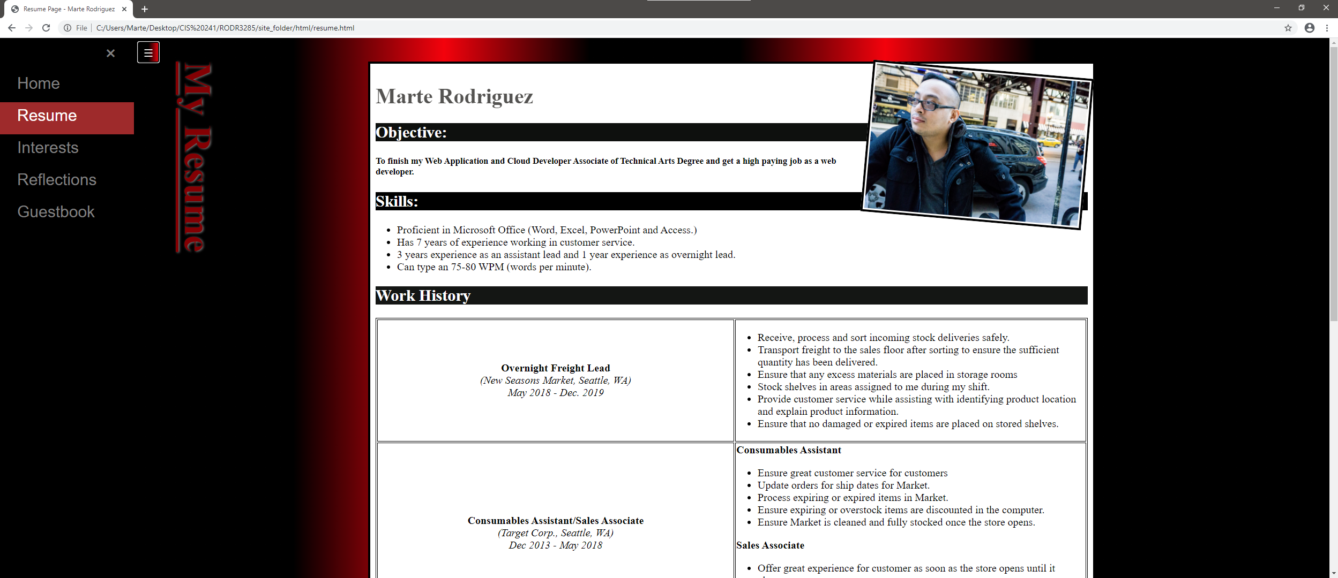

**Notice the resume page has an active color when you are in the page.**

Screenshot 9 – Resume page (smaller screen) 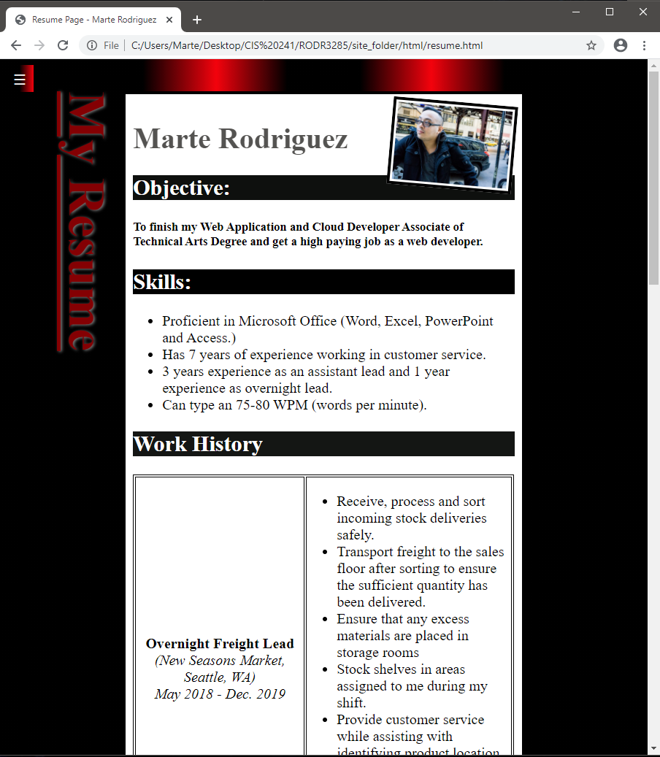

**Resume page in smaller screen.**

Screenshot 10 – My Interests page (small screen) 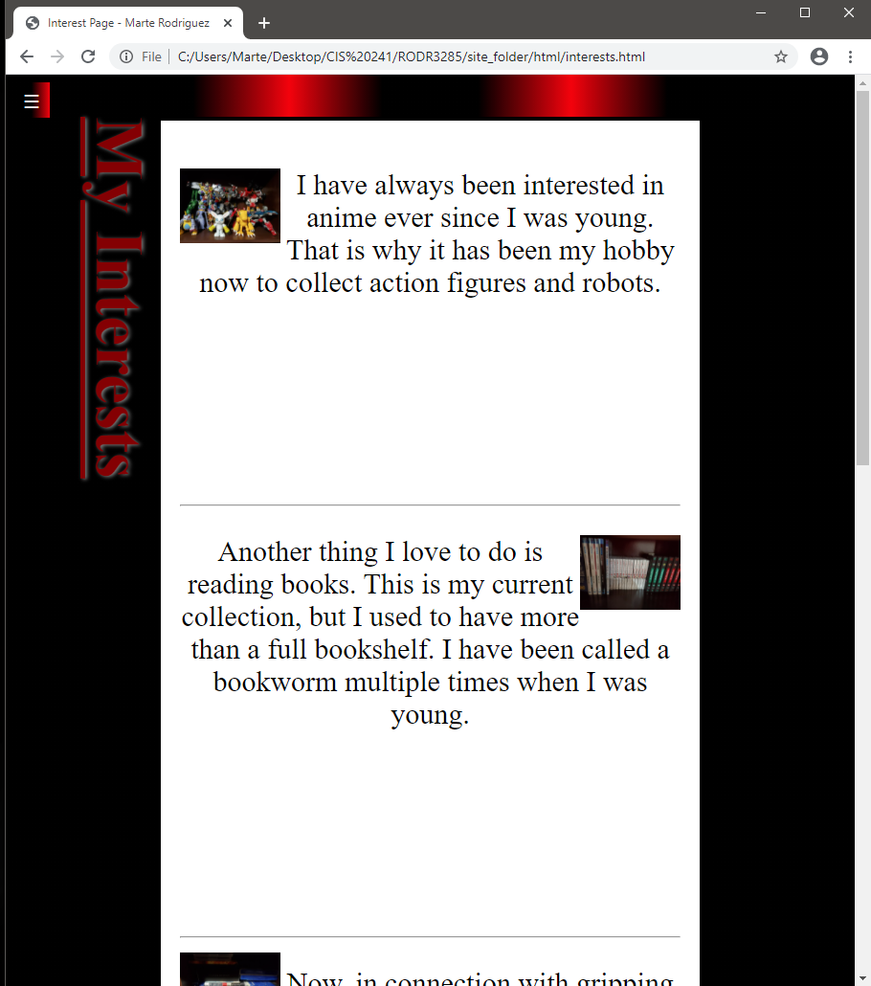

Screenshot 11 – My interests page listed links (small screen)

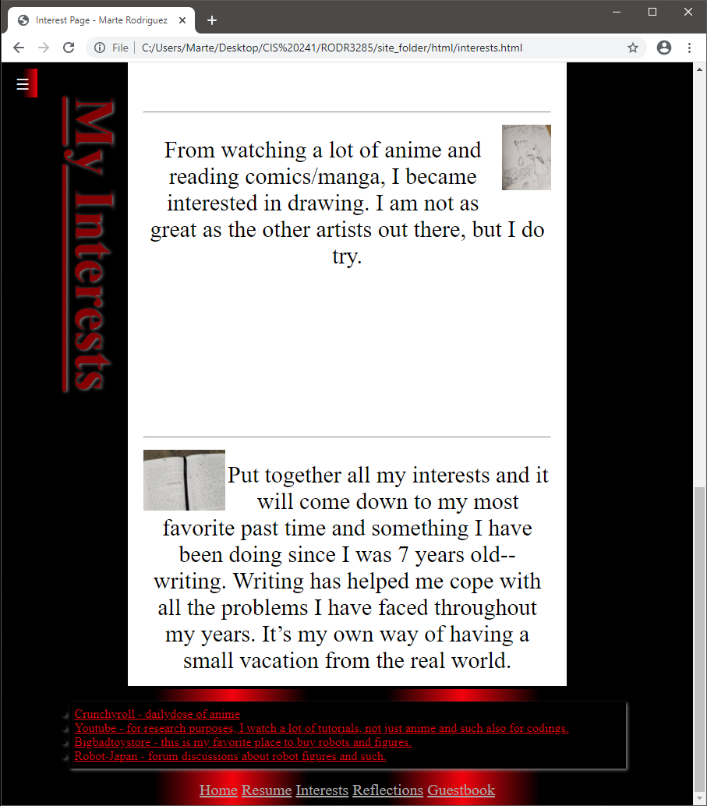

**My listed links in the bottom of the page on top of the footer.**

Screenshot 12 – My interests page in full screen 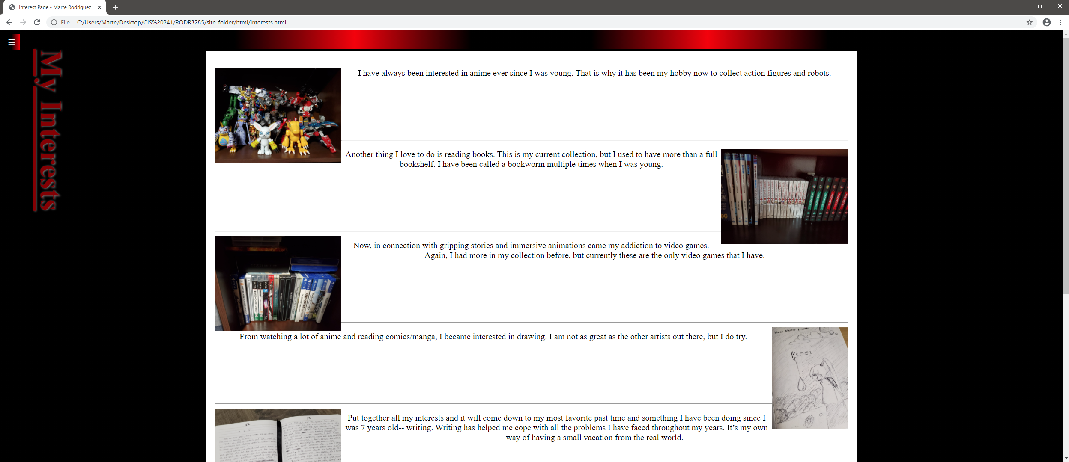

Screenshot 13 – My reflection page in full screen 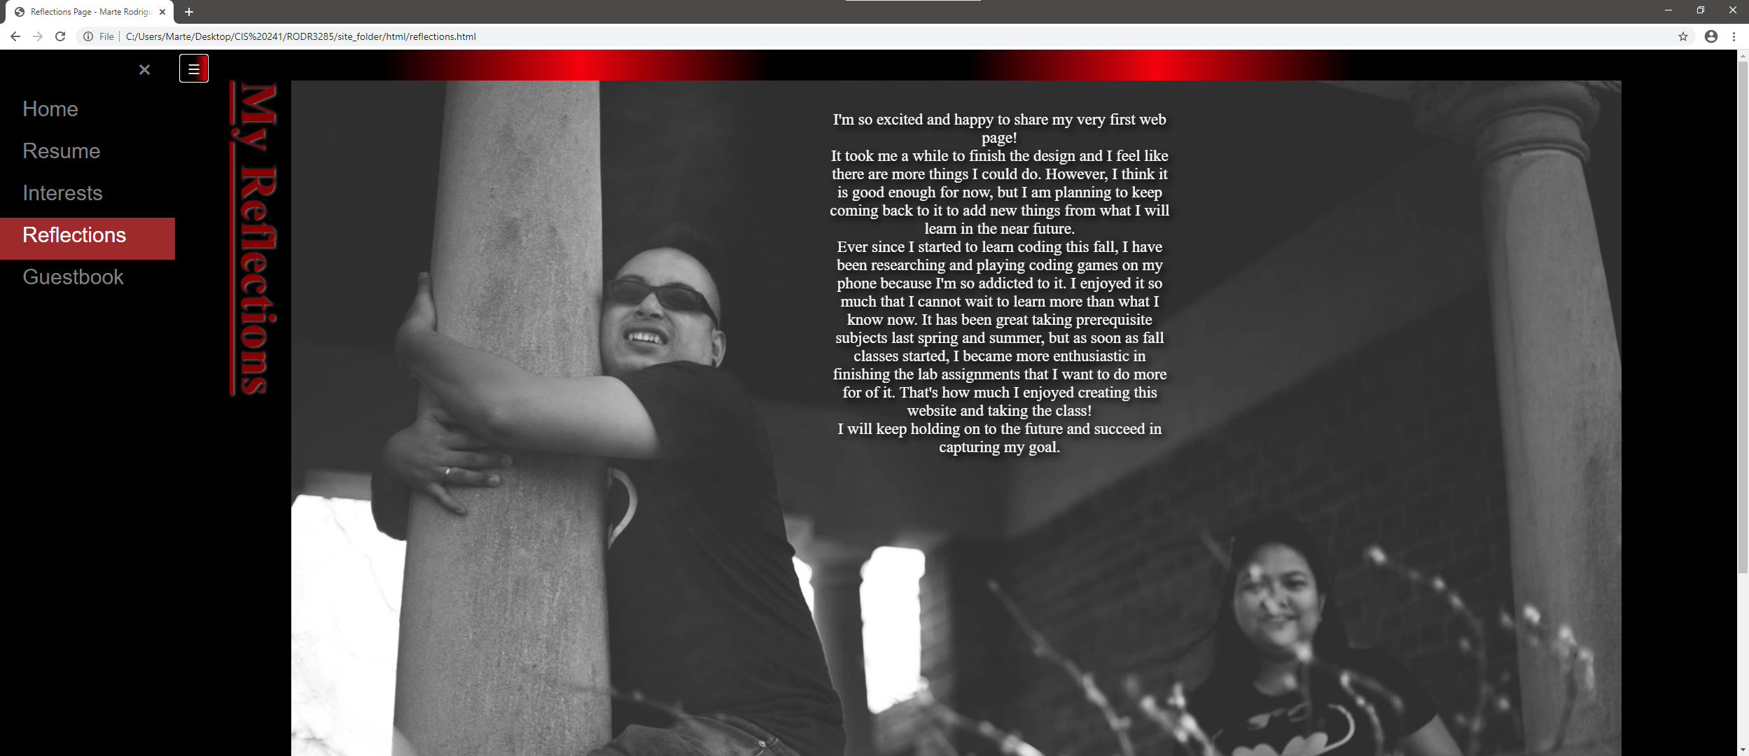

Screenshot 14 – My reflection page in small screen

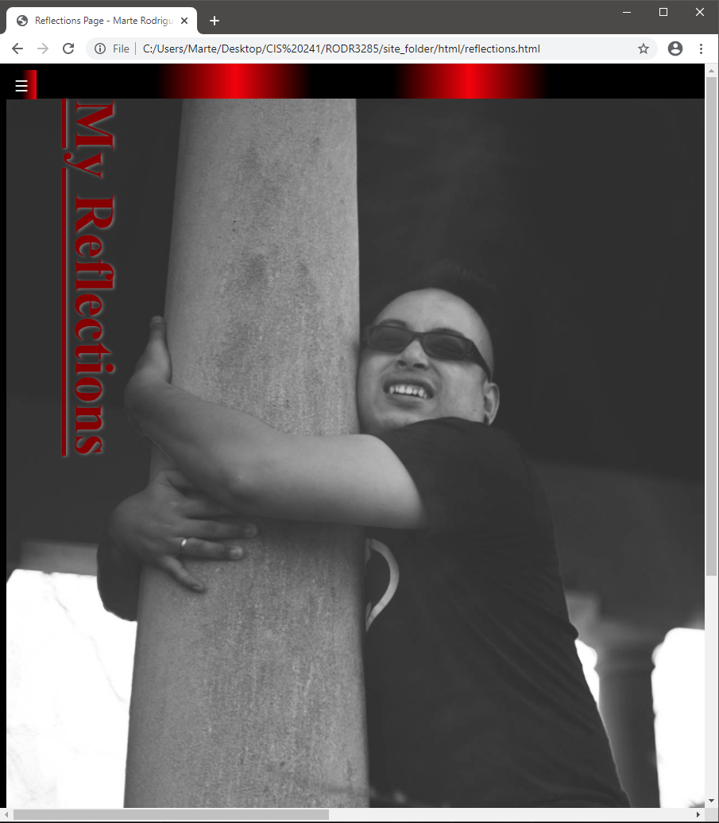

**Moving the scroll bar on right would show my reflection text in the picture.**

Screenshot 15 – Reflection page right side. (small screen) 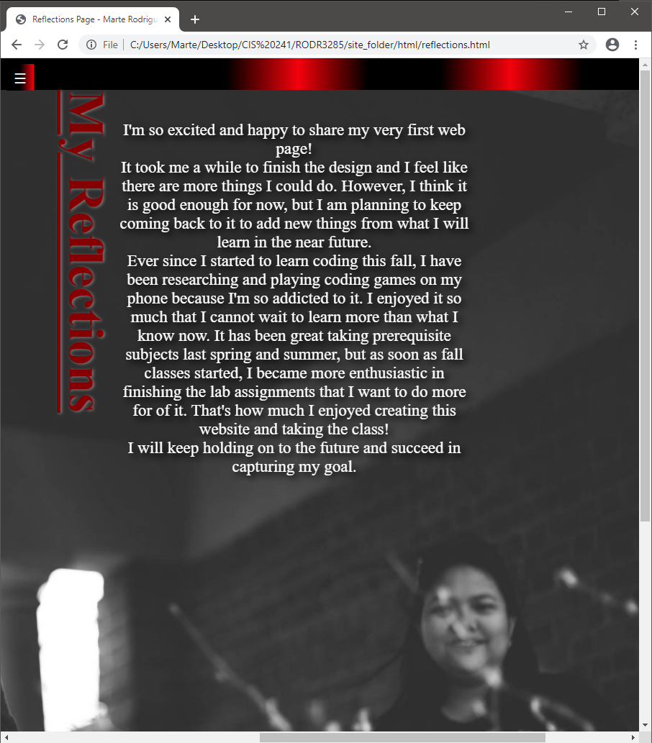

Screenshot 16 – Guestbook in small screen 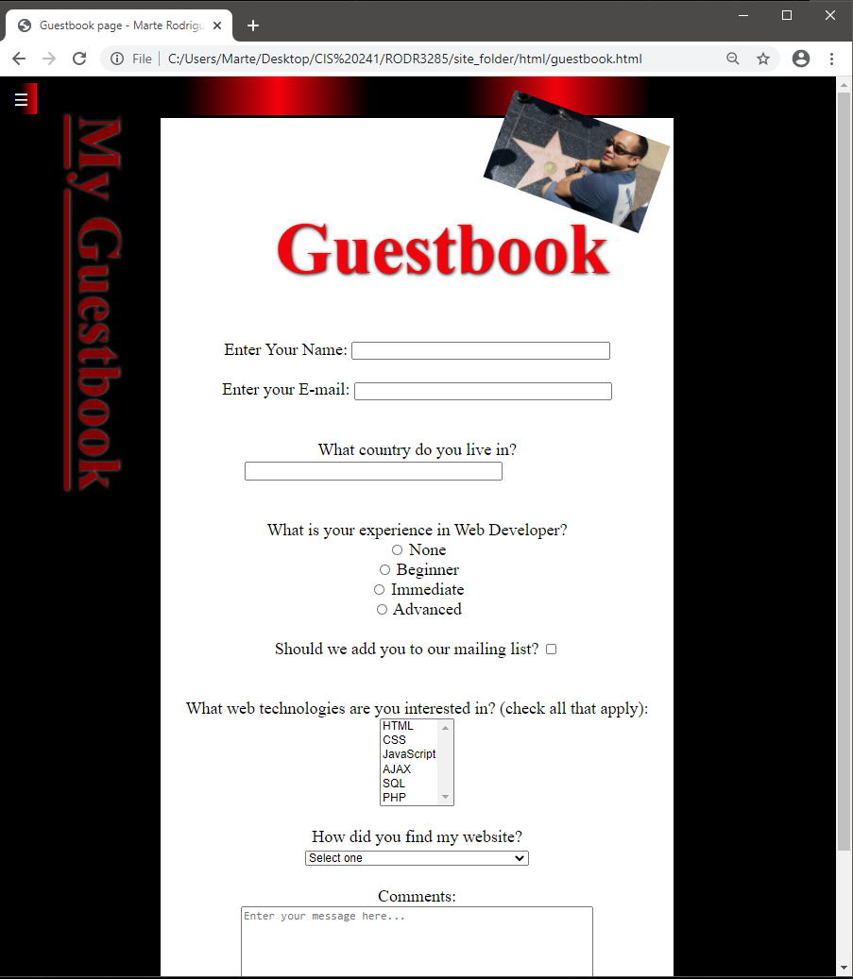

**Guestbook to fill up for all my visitors.**

Screenshot 17 – Guestbook full screen 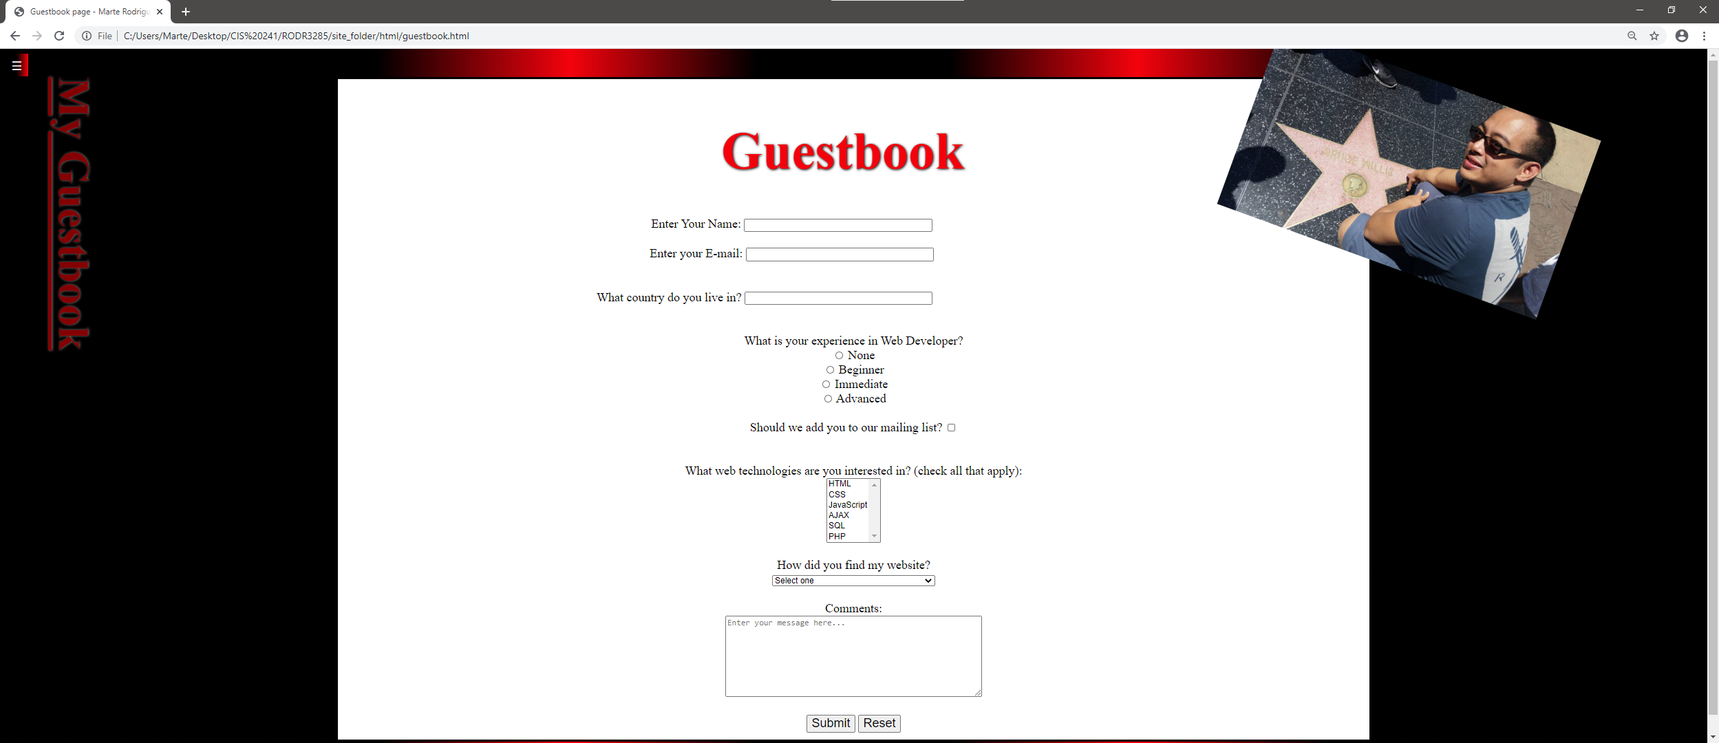

Screenshot 18 – Guestbook full screen with navigation panel open 